Running an Ebola Clinic in Sierra Leone Is All About Containment - And Chlorine
December 21, 2014 | Wired.com
BY ERIKA CHECK HAYDEN

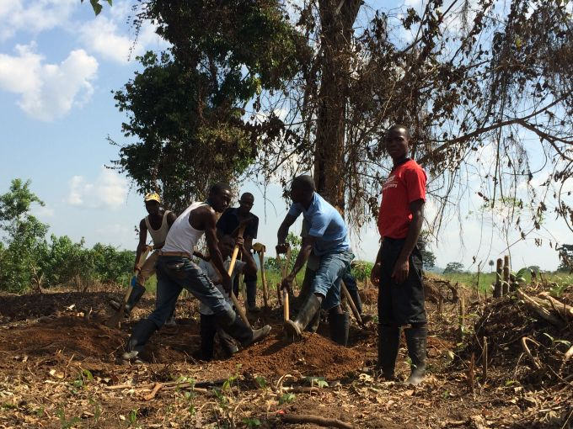
Gravediggers prepare fresh graves at an Ebola treatment center near Kenema. Image by Erika Check Hayden. Sierra Leone, 2014.
FREETOWN, Sierra Leone—Treating patients with the deadly Ebola virus takes doctors, drugs, and a whole lot of chlorine.
The Ebola treatment units being deployed across Sierra Leone are built by teams of logisticians—“logs” in disaster aid parlance—who can drop into a bare field and construct a mini city in a matter of weeks. But these cities are full of some of the world’s sickest, most contagious patients.
Everything in the centers serves two goals: helping patients get better, and keeping them from infecting their caretakers. “It’s about working like you’re in the army and behaving like you’re in a human environment,” says Claire Dorion, a water, hygiene and sanitation referent for Doctors Without Borders, the aid group based in Switzerland. Dorion and five other logisticians recently spent 14 days and nights building an Ebola treatment center in Freetown, on the grounds of a secondary school. There were 23 patients on the day I visited, a week after it opened on December 8, and workers were building wards for 60 more. Here’s how it all works.
Shelter
Patients stay in tents or wood-framed structures with tarped walls. “Confirmed” patients—those who have tested positive for Ebola—are segregated from “suspect” patients to reduce the risk of patients infecting each other. A unit in Freetown is testing a design with individual cubicles in the suspect wards, an attempt to further cut that risk.
It gets hot inside the huge white treatment tents, so patients usually have places to sit outside. A center in Kerry Town, near Freetown, run by the non-profit group Save the Children, has built two grass-roofed shade huts like the ones seen in every Sierra Leonean village.
Staff
Each treatment center requires hundreds of workers—close to 300 right now for the Doctors Without Borders unit in Freetown, and 500 to treat 35 patients at Save the Children’s center in Kerry Town. Sierra Leoneans work alongside expatriates, and their jobs range widely. There are doctors, nurses, hygienists, chefs; people to wash boots and scrubs; staff for the morgue, and—at some centers—gravediggers to bury the deceased. Social workers call relatives and find homes for orphaned children.
At a Doctors Without Borders treatment center in Bo, discharged patients receive a standard package of food, clothes, condoms (90 for men, 30 for women; Ebola survivors still carry the virus at low levels in their semen for months after they recover), and early grief counseling. Almost everyone who comes out has lost someone.
Movement
Every center has a high-risk area where patients are treated and a low-risk area where the workers do their tasks: charting, eating, laundering. They have only only one way in and one way out of the patient zones: through the dressing and undressing tents. Fencing separates the inside and outside, usually by at least 2 meters, a sufficient distance to protect visitors and workers from infectious projectile vomit.
Patients enter the center through a triage zone. At the site in Freetown, the triage zone has a wooden partition to physically separate patients from caretakers. It’s a new feature designed in the wake of staff infections that occurred at Doctors Without Borders centers in Bo and Monrovia, Liberia.
Patients go out one of two ways: in a body bag, or with a celebration. At a treatment center run by the International Federation of Red Cross and Red Crescent Societies near Kenema, survivors remove the soiled clothes they wore while sick and bathe in a cubicle nicknamed the “happy shower.” They then change into new clothes, usually smiling, though still weary from their struggle with the disease.
Personal protective equipment
Protective gear is required for everyone entering the high-risk area—the patient zone. It is donned according to strict guidelines and covers every inch of skin. For Doctors Without Borders, it goes on like this: boots and scrubs, a pair of nitrile gloves, Tyvek coverall, respirator, hood, apron, goggles, and a second pair of gloves (rubber for the hygienists, latex for the medical staff to help ensure greater manual dexterity).
Undressing is the riskiest part of working in the gear, because of the danger that contaminants will touch exposed skin. Workers are sprayed with bleach solution before removing it all, again in strict order, washing their hands between each step. Coaches supervise both dressing and undressing. In Freetown, Doctors Without Borders is going through about 200 sets of protective equipment daily. Kerry Town will go through 800 sets per day if it reaches its full capacity of 80 patients later this month.
Pharmacy
Treatment center pharmacies are stocked with drugs to treat the dehydration, secondary infections, pain, and weakness caused by Ebola. There are oral rehydration salts, intravenous fluids, antibiotics, vitamins, pain medication, paracetemol to reduce fever, and anti-nausea drugs.
Other conditions are a fact of everyday life here, so the centers stock medicines for those, too: malaria, HIV, parasitic infections, diabetes. And there are the drugs that are needed when all of that fails: anesthetics, morphine, and antipsychotics.
Water
Essential for the constant decontamination of everything at the treatment center (see also: chlorine, below). The Doctors Without Borders Freetown site is hooked into the town water supply but keeps 25 cubic meters of water in storage tanks on site in case that goes out. Kerry Town has no municipal water supply, and so has drilled boreholes.
Every treatment center has its own purpose-built system of pipes, taps, septic tanks and storm sewers to store and send this water everywhere it’s needed—the wards, the laundry, the showers, the kitchen, the latrines and the ubiquitous hand-washing stations. Keeping this whole system running smoothly is a major logistical challenge: On one day I visited Kerry Town, the site was in the process of replacing its taps—the chlorinated water they dispense had worn them out in just over a month—and was testing a new borehole.
Chlorine
The defining element of a treatment unit is chlorine. Staff and patients wash their hands in it; the laundry machines use chlorinated water to clean the workers’ scrubs; it’s poured into buckets at patients’ bedsides to disinfect their vomit—and into body bags when the deceased are placed inside. The gravel on the ground is white with the stuff in places.
Each treatment unit mixes its own chlorinated water, usually in two strengths: 0.5 percent chlorine for heavy-duty disinfection—boots, rubber gloves, latrines, the wards—and 0.05 for hand washing. It’s piped through the treatment center and emerges at color-coded faucets: Doctors Without Borders uses yellow for the weaker solution and red for the strong stuff.
Hygiene is an understandable obsession. Doctors Without Borders has 170 hygienists in Freetown, and some of them are in the patient zone almost all the time. That keeps the patient area safer for workers, and boosts patient morale—the hygienists don’t just police good habits, but also clean up. “If the patients are lying in a pool of vomit, their mental health is not going to be good, and they won’t have the strength to fight,” Dorion says.
Power
Generators are mandatory. Even where there is “town power,” it’s unreliable. Kerry Town uses electricity for run-of-the mill needs like lighting, and storing medicines that require refrigeration, like morphine. But it also has a few specialty power needs, like an onsite lab with all the machinery needed to run diagnostic tests for Ebola and other diseases. The British Army is running a clinic on site for health care workers infected with Ebola; it has supplies I haven’t seen elsewhere in the country, like refrigerated, banked plasma, and blood.
Death
No matter how hard everyone works, death is an inevitable part of life in an Ebola treatment center. I visited a graveyard at the Red Cross treatment center in Kenema, where workers were digging fresh graves. Other organizations don’t do burials but have a morgue.
Keeping all of this running requires a military mindset. Doctors Without Borders in particular is famous—perhaps infamous—for protocols governing everything within the clinic. There’s a reason for this: If everyone follows the rules, it allows them to worry less about themselves and more about the patients. “If you are following the protocols 100 percent,” Dorion said, “you are not at risk at all.”

