Poetry Workshop: Writing in Response to Images

Workshop Description:
You've probably heard that "a picture is worth a thousand words." There are also a thousand ways to interpret a picture. How can you use poetry to illuminate the many possible interpretations of an image, and/or to give voice to your own interpretation? How can powerful photography and poetry, together, be used to make personal connections with global issues and to highlight the world's under-reported stories?
In this workshop, you will write ekphrastic poems based on powerful photography from global news stories. By doing so, you will explore the stories photos tell, make personal connections to those stories, and amplify under-represented voices while making your own voice heard.

Vocabulary:
- Ekphrastic poem: A poem that responds to a work of visual art—generally a painting, sculpture, or photograph. Ekphrasis is a Greek word that translates to description, but contemporary ekphrastic poems usually go beyond description to speak to or from the perspective of the artwork/its subject(s).
- Photojournalism: Photography that tells a true story.
- Under-reported story: A story that isn't typically featured in major news headlines, or otherwise doesn't receive very much attention.

Model Poems and Discussion:
1. Explore the photos by Moises Saman from the news story “Iraq's Post-ISIS Campaign of Revenge,” written by Ben Taub and published in the New Yorker.
2. Look at the photos without reading the captions. What themes emerge? What feelings do the photos evoke? Write them down. Then, read the captions. Does the added information change or add to your list? Finally, reflect: How can the themes present in these photos connect with your life?
3. Read “Aljanat fi Alkharab (Heaven in Ruins)” by Selam Weimar, a poem written by a student in response to the photos you just explored.
4. Reflect and write down your responses to the following questions:

1. What language in the poem jumps out to you as beautiful or interesting? What poetic devices (such as rhythm, repetition, or metaphor) do you notice?

2. What evidence of the poem's connection to the photo story can you identify?

3. What does the poem add that is not already present in the photo story?

4. Look back at the list you made in step 2. Does the poet explore one or more of the themes or feelings you wrote down? Did you write down more themes or feelings that the poet did not explore?

Practice: Writing an Ekphrastic Poem
Ekphrastic poems can help us see how many different ways an image can be interpreted. Practice observing closely and diversifying your perspectives on the following photograph from Natalie Keyssar's photo story published in California Sunday Magazine, "Venezuela's Days of Upheaval."
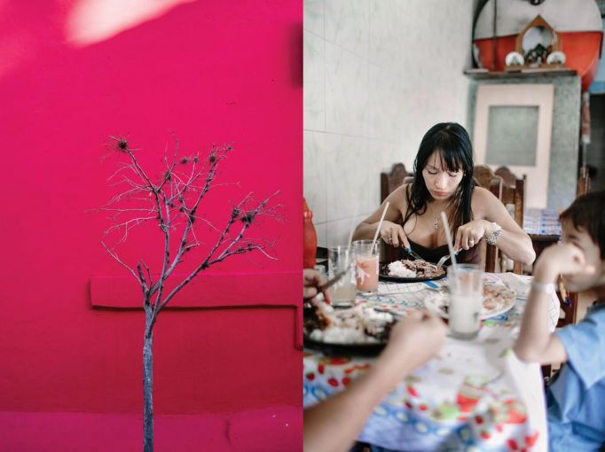
Caption: LEFT: A tree stands in a small park near a polling place in Catia, a neighborhood of Caracas, the day government supporters lost their majority to the opposition in parliament. RIGHT: A family eats at a restaurant in Antímano, Caracas. Images by Natalie Keyssar. Venezuela, 2016.
1. Examine Natalie Keyssar's photo and read its caption. On a sheet of paper, write down words and phrases that come to mind. They can describe what you see—colors, objects, expressions—or the feelings and themes that arise from exploring this photo. You are creating a word bank; you do not need to write in full sentences.
2. Read this statement Natalie Keyssar made on her photojournalism project:
Since Hugo Chávez died in March 2013, Venezuela has spiraled into crisis. The new president, Nicolás Maduro, has struggled to hold together the socialist coalition his predecessor formed.
Shortages in food, electricity, and medicine have led to riots; crime has spiked the already astronomically high murder rate; meteoric inflation, corruption, and price controls have caused the cost of some basic necessities to skyrocket.
"This work is about inequality," says photographer Natalie Keyssar, "and a level of tension and sometimes danger so powerful in daily life it's almost palpable." Her photos also capture a pivotal moment for "an egalitarian dream in a country that had the natural resources to pursue that dream but now seems to be in danger of falling apart."
2. Reflect on the following questions:
- What are the themes present in this photojournalism project? How can you see them, visually, in the image above?
- How can you connect with those themes?
- If you were using this photo to write an ekphrastic poem, what perspectives could you write from? (Remember: you do not have to write from the perspective of a person, nor does the perspective you write from need to be featured in the poem; it may be a historical figure's, an outside observer's, or your own.) Come up with as many as possible.
3. What themes, feelings, or details in the photo resonate most with you? What or who is absent from the photo? Use your word bank and your reflections to practice writing an ekphrastic poem. If you would like, you can use this formula:
- Line 1: “Portrait of ___.” (person, object, theme, feeling, metaphor in the photo).
- Line 2: “Not a portrait of ___.” (person, object, theme, feeling, metaphor not in the photo).
- Repeat this pattern at least three times.

Writing Your Ekphrastic Poem:
1. Select the photo / themes with which you connect most. Read the photo's caption and the short text associated with it to get some background in the story the photo is telling.
2. Create a word bank with words and phrases that capture details, themes, and feelings that stand out to you in the photo.
3. Write your poem! The only requirement is that your poem respond to the photo you chose by engaging with its story, themes, and/or visual content. Need help to get started? Try one of these approaches:
- Start by describing the photo. In addition to visual description, tell your reader about the smells, the sounds, the textures. Then, take us beyond the frame: what lies there? What isn't pictured?
- Choose a small detail in the photo, and write from its perspective. What is it doing in the photo? What is its history? What does it have to say about the themes of the photo at large?
- Return to the practice exercise, writing in couplets (rhymed or unrhymed) that follow the pattern: "Portrait of _____." / "Not a portrait of _______." Write at least six sets of couplets.

4. If you would like to share your poem with the Pulitzer Center for the chance to be published, email education@pulitzercenter.org.

